Union and Union all

1. Add two sources as done previously
2. Now click on + you will see union select that

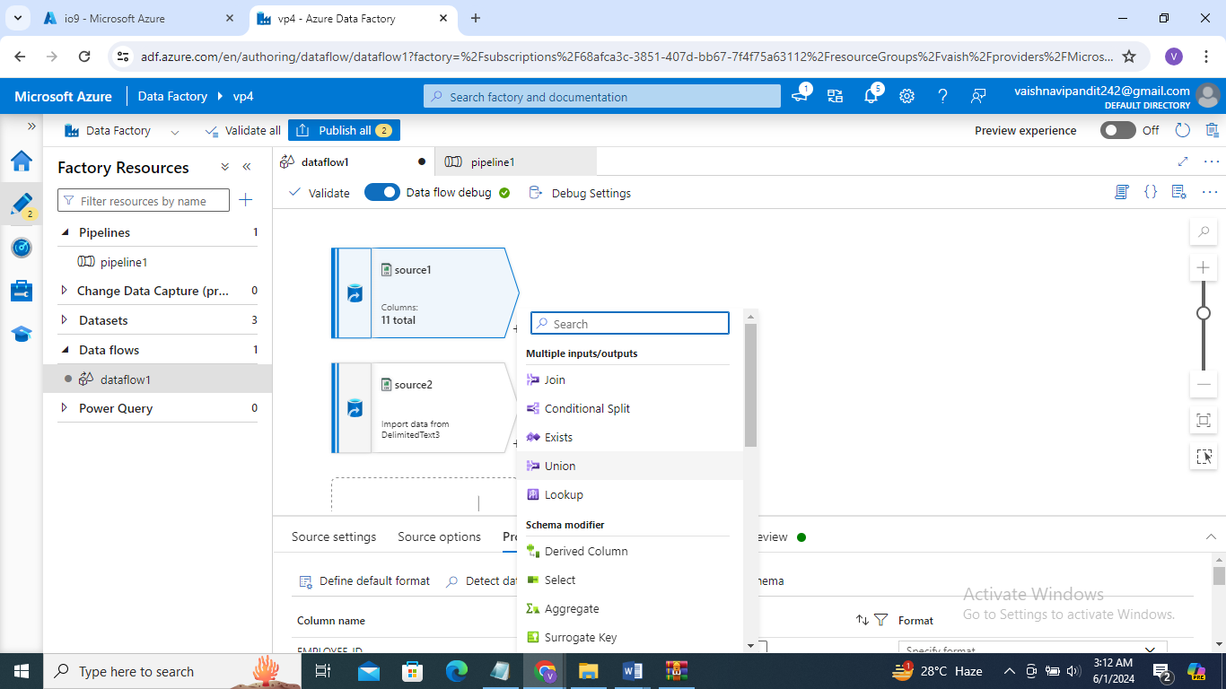

1. Now go to union

Select union with as source2

